Digital Egypt Pioneers Initiative رواد مصر الرقمية
Round 4 الدورة الرابعة
2025 - 2026 2025 - 2026

Track: AI & Data Science - Microsoft Machine Learning Engineer
Group Code: ONL4_AIS2_S7
Instructor: Eman Elgalad
Company Name: Skills Dynamix



Project Name

"AI-Powered Predictive Maintenance for Industrial Equipment"
No. | Name
1 | Moaz Osama Esamil Hataba (TL)
2 | Abrar Ashraf Shaban Ahmad
3 | Marwan Muhammad Darwish Ammar
4 | Yussef Ahmad Muhammad Elshamy
5 | Salma Muhammad Nageh Abdul-Hamid
6 | Nour-Eldin Kamel Muhammad Hasanein

Task |  | Page No. | Evaluation
System Actors & Interactions |  | 5
Use Cases |  | 7
Use Case Diagram |  | 10
Functional Requirements |  | 11
Non-Functional Requirements |  | 13
System Capabilities |  | 15
System Constraints |  | 16
Architecture Style |  | 17
High-Level System Components |  | 18
System Interactions |  | 20
Software Architecture |  | 21

System Analysis
&
Design
Main Screens & Interface Components:
- Login & Authentication Screen
  - Purpose:
    - Provide secure access to the predictive maintenance platform.
  - Main Components:
    - Modern dark-themed login and registration interface.
    - User signup with validation and default role assignment.
    - User credentials securely using password hashing and SQLite database integration.
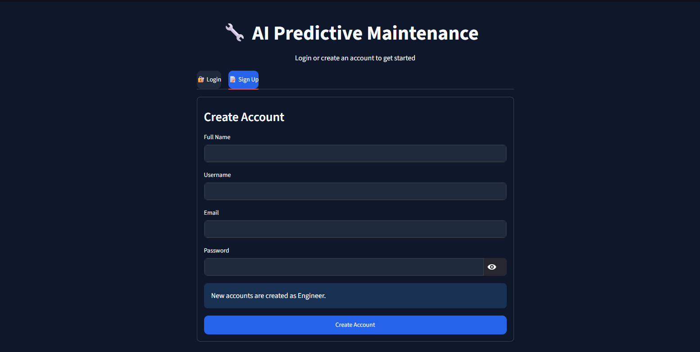
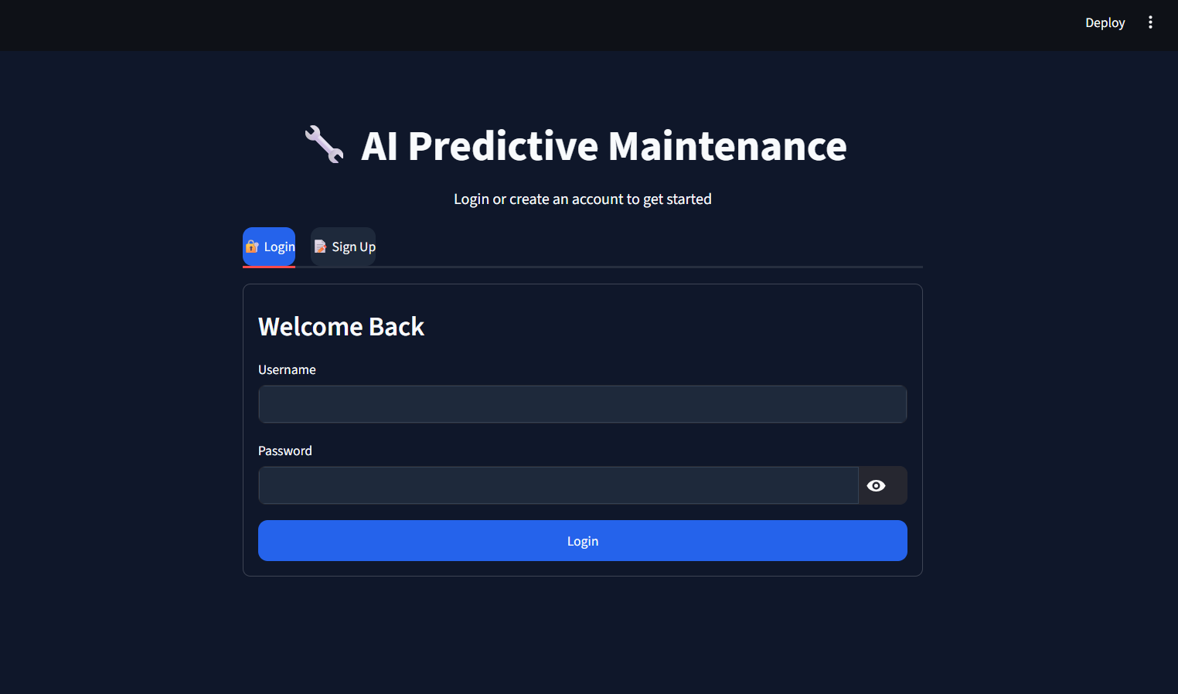
- Dashboard Home Screen
  - Purpose:
    - Provide an overview of the system status and equipment health.
  - Main Components:
    - Total monitored engines.
    - Current health status indicators.
    - Average predicted RUL.
    - Critical equipment alerts.
    - Summary charts and statistics.

- Prediction Screen
  - Purpose:
    - Allow users to perform Remaining Useful Life prediction.
  - Main Components:
    - Dataset selection.
    - Engine selection.
    - Sensor input information.
    - Prediction button.
    - Predicted RUL value.
    - Equipment health classification.

- Explainable AI Screen
  - Purpose:
    - Explain model decisions and improve user trust.
  - Main Components:
    - Username and password fields.
    - User authentication controls.
    - Error messages and validation feedback.
    - Role-based access management.
    - Monitor model performance during simulated real-time prediction.

- History & Monitoring Screen
  - Purpose:
    - Track previous predictions and equipment behavior over time.
  - Main Components:
    - Username and password fields.
    - User authentication controls.
    - Error messages and validation feedback.
    - Role-based access management.

- Maintenance Management Screen
  - Purpose:
    - Provide secure access to the predictive maintenance platform.
  - Main Components:
    - Username and password fields.
    - User authentication controls.
    - Error messages and validation feedback.
    - Role-based access management.

- RAG Maintenance Assistant Screen
  - Purpose:
    - Provide AI-based maintenance support using the knowledge base.
  - Main Components:
    - Username and password fields.
    - User authentication controls.
    - Error messages and validation feedback.
    - Role-based access management.

- Reports Screen
  - Purpose:
    - Generate and export maintenance reports.
  - Main Components:
    - Username and password fields.
    - User authentication controls.
    - Error messages and validation feedback.
    - Role-based access management.
Design Principles:
- UC-1: Dataset Selection
  - Primary Actor
    - Maintenance Engineer.
  - Preconditions
    - The NASA CMAPSS dataset is available.
    - The system is initialized.
  - Main Flow
    - User selects FD001–FD004.
    - User selects Engine ID.
    - System validates selection.
    - System validates the selected dataset and engine.
    - Selected data is prepared for simulation and prediction.
  - Output
    - Selected dataset.
- UC-2: Automatic Real-Time Monitoring
  - Primary Actor
    - Maintenance Engineer.
  - Preconditions
    - Dataset selected.
    - A trained prediction model is available.
    - Simulation started.
  - Main Flow
    - System automatically streams sensor readings.
    - Dashboard updates every cycle.
    - Backend predicts RUL continuously.
    - Equipment health status is updated.
    - Visualization refreshes automatically.
  - Output
    - Continuous equipment monitoring.
- UC-3: Predict Remaining Useful Life (RUL)
  - Primary Actor
    - Maintenance Engineer.
  - Preconditions
    - A trained machine learning model is available.
    - A NASA CMAPSS dataset scenario has been selected.
    - The backend API is running and accessible.
Color Scheme:
- Dataset & Simulation
  - FR-01
    - The system shall allow users to select a NASA CMAPSS dataset scenario (FD001–FD004).
  - FR-02
    - The system shall allow users to select an engine from the selected dataset.
  - FR-03
    - The system shall automatically load and validate the corresponding sensor data before starting the simulation.
  - FR-04
    - The system shall simulate real-time sensor data streaming by sequentially replaying operational cycles from the selected NASA CMAPSS dataset.
- Prediction Engine
  - FR-05
    - The system shall preprocess incoming sensor data using the same preprocessing pipeline applied during model training.
  - FR-06
    - The system shall predict the Remaining Useful Life (RUL) using the trained machine learning model.
  - FR-07
    - The system shall continuously update the Remaining Useful Life (RUL) prediction after each simulated operational cycle.
  - FR-08
    - The system shall classify equipment health status (Healthy, Warning, or Critical) based on the predicted Remaining Useful Life (RUL).
- Explainable AI
  - FR-09
    - The system shall generate SHAP-based explanations for each prediction to identify the contribution of individual sensor features.
  - FR-10
    - The dashboard shall display SHAP values, feature importance rankings, and explanation visualizations for every prediction.
Typography:
- Performance
  - NFR-01
    - The system shall generate Remaining Useful Life (RUL) predictions within one second after receiving valid sensor data under normal operating conditions.
  - NFR-02
    - The dashboard shall load completely within three seconds under normal operating conditions.
- Availability
  - NFR-03
    - The system shall remain available and responsive throughout each simulation session without unexpected interruptions.
- Reliability
  - NFR-04
    - The system shall produce consistent prediction results when processing identical input data and model configurations.
- Security
  - NFR-05
    - The system shall validate and sanitize all user inputs, rejecting invalid dataset selections, engine IDs, and malformed requests before processing.
- Usability
  - NFR-06
    - The system shall provide a simple and intuitive user interface.
  - NFR-07
    - Predictions, equipment health status, SHAP explanations, simulation progress, and visualizations shall be clearly displayed and easy to interpret.
- Maintainability
  - NFR-08
    - The codebase shall follow PEP8 coding standards.
  - NFR-09
    - The system shall follow a modular architecture to support maintainability and extensibility.
Accessibility Considerations:
- Data Simulation & Monitoring
  - The system is capable of simulating real-time sensor data by replaying CMAPSS dataset operational cycles.
  - The system can continuously monitor equipment conditions during simulation execution.
- Predictive Analytics
  - The system can estimate Remaining Useful Life (RUL) for equipment using a trained machine learning model.
  - The system can classify equipment health status into different operational states (Healthy, Warning, Critical).
- Data Visualization
  - The system provides interactive visualization of sensor readings and degradation trends.
  - The system displays real-time dashboard updates during simulation execution.
- Explainability
  - The system can generate explanations for predictions using feature contribution analysis (SHAP-based interpretation).
  - The system can highlight the most influential sensor features affecting model output.
- Reporting & Decision Support
  - The system can generate maintenance and performance reports.
  - The system supports maintenance decision-making by providing prediction insights and recommendations.

User Experience Goals:
- Data Constraints
  - The system is limited to the NASA CMAPSS dataset (FD001–FD004).
  - System performance depends on the quality and structure of the provided dataset.
- Model Constraints
  - Predictions are dependent on a pre-trained machine learning model.
  - Model accuracy is limited by training data quality and feature engineering.
- Architectural Constraints
  - The system relies on a REST-based backend architecture for communication.
  - The system uses a modular pipeline (preprocessing → prediction → explanation).
- Runtime Constraints
  - The system operates under simulated real-time conditions, not actual hardware sensor streams.
  - Performance depends on computational resources available on the host machine.
- Platform Constraints
  - The system is implemented in Python and must run in a Python-supported environment.
  - The system is compatible with modern web browsers for dashboard access.
- Dependency Constraints
  - The system depends on external libraries for:
    - Machine learning (e.g., scikit-learn / XGBoost).
    - Explainability (SHAP).
    - Web framework (FastAPI / Streamlit).

